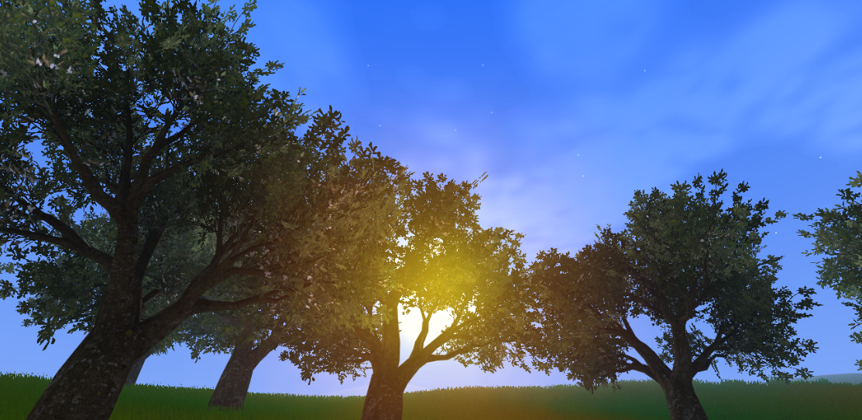


- Thanks for bought “SkyProject System”, if you pirated it consider buying it atleast for the effort of the developer, thanks.
- More Updates will be coming.
- If you have any suggestion or question, send an email to neo5icekcore@gmail.com
- If you have any problems or bugs i will try to resolve it as soon as i can.

FIRST SETTINGS:
- You only need to drag and drop to the scene the “SkySphere” prefab this prefab is located inside the prefab folder inside the SkyProject folder.
- If you want to edit the colors you need to go to “SkySphere Manager” inside “SkySphere” in the scene; like in the image:
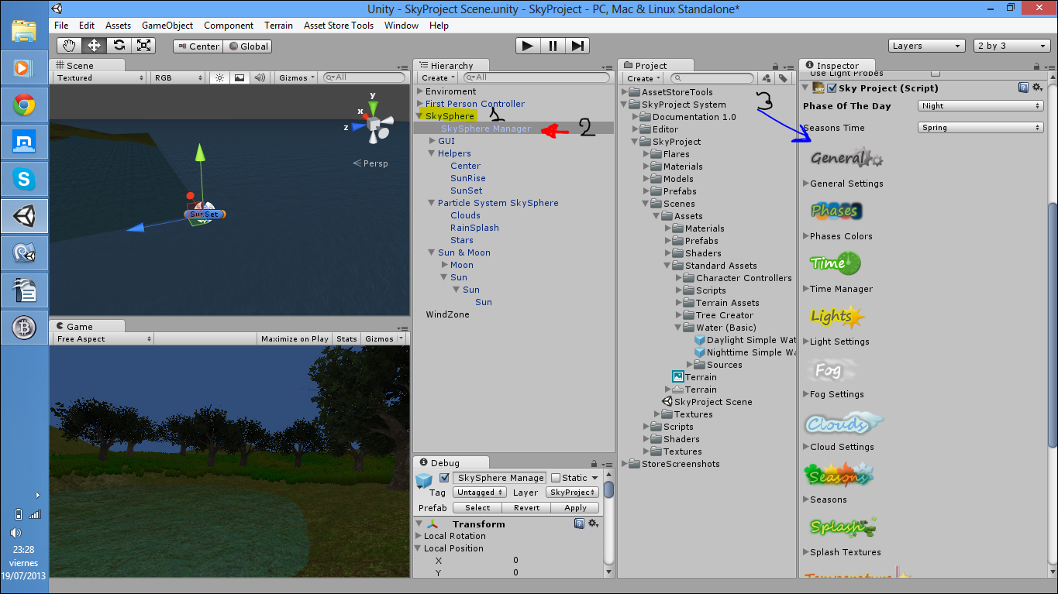

1- GENERAL SETTINGS:
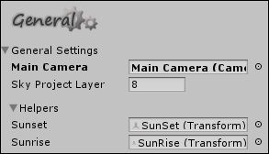
- Main Camera: You need to put here your Main Camera (Drag and drop)

- Sky Project Layer: It contain the number of the system layer, the default is 8.

- Helpers: It contain information about the trajectory, it's very important.
  - SunSet: You need to set up here the SunSet helper, the prefab contain it so no problems.
  - SunRise: It's like SunSet Helper.

2- PHASES COLORS:
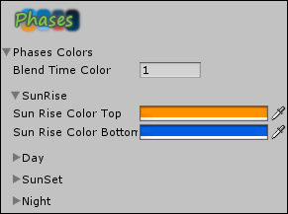
- Phases Colors:
  - Blend Time Color: You can change the speed of the transition between the colors; Higher number means higher time between colors.

- SunRise, Day, SunSet, Night: They contain the colors of the pashes.

3- TIME MANAGER:
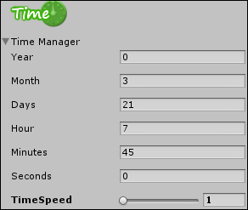
- Time Manager:
  - Year: It contain the years of the game.
  - Month: It contain the months of the game.
  - Days: It contain the days of the game
  - Hour: It contain the hours of the game.
  - Minutes: It contain the minutes of the game.
  - Seconds: It contain the seconds of the game.
  - TimeSpeed: You can change the speed of the Game; more value, more speed.

4- LIGHT SETTINGS:
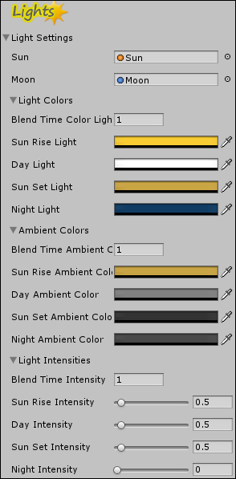
- Light Settings:
  - Sun: You need to set up the Sun here if you want dinamic Sun (The prefab contains it).
  - Moon: You need to set up the Moon here if you want dinamic Moon (The prefab contains it).

  - Light Colors:
    - Blend Time Color Light: This number set up the speed between the colors of the light; higher value, higher time between the transitions.
    - Sun Rise, Day, Sun Set, Night Colors: They are the colors of the lights depending of the phases.

  - Ambient Colors:
    - Blend Time Ambient Color: This number set up the speed between the colors of the ambients; higher value, higher time between the transitions.
    - Sun Rise, Day, Sun Set, Night Colors: They are the colors of the ambient depending of the phases.

  - Light Intensities:
    - Blend Time Intensity Light: This number set up the speed between the intensities of the light; higher value, higher time between the transitions.
    - Sun Rise, Day, Sun Set, Night Intensity: They are the values of the intensities depending of the phases.

5- FOG SETTINGS
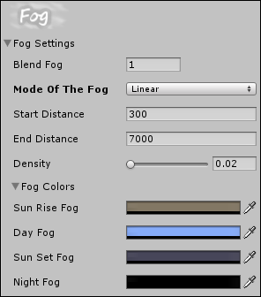
- Fog Settings:
  - Blend Fog: This field is for control the speed of the transition between the fogs colors.
  - Mode of The Fog: You can change the mode of the fog here.
  - Start Distance (Linear mode): This field is for control the start distance of the linear fog.
  - End Distance (Linear mode): This field is for control the end distance of the linear fog.
  - Density (Exp and Exp2 modes): This field determine the density of the Exp's fog.

  - Fog Colors:
    - Sun Rise, Day, Sun Set, Night Fog: Colors for the fog depending of the phases.

6- CLOUD SETTINGS:
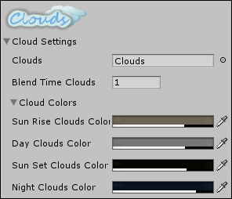
- Cloud Settings:
  - Clouds: You need to put here the clouds (The prefab contains it).
  - Blend Time Clouds: This is the speed of the transition between the colors.

  - Cloud Colors:
    - Sun Rise, Day, Sun Set, Night Clouds Color: Colors for the clouds depending of the phases.

7- SEASONS:
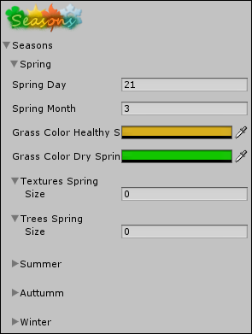
- Seasons
  - Spring, Summer, Auttumn, Winter:
    - Day: The day when the season starts.
    - Month: The month when the season starts.
    - Grass Color Healthy: Healthy Color of the grass depending of the season.
    - Grass Color Dry: Dry Color of the grass depending of the season.
    - Textures: You can change the terrain textures here, the order is determined by the terrain and you can left textures if you don't want to change them.
    - Trees: The same as the Textures field but for trees.

8- SPLASH TEXTURES:
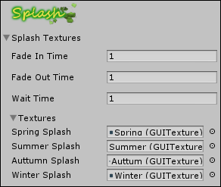
- Splash Textures:
  - Fade In Time: The speed of the “In Fade”
  - Fade Out Time: The speed of the “Out Fade”
  - Wait Time: The time to wait when the In fade ends and the Out fade starts.

  - Textures:
    - Spring, Summer, Auttumn, Winter Splash: The textures for the splash depending of the seasons.

9- TEMPERATURE:
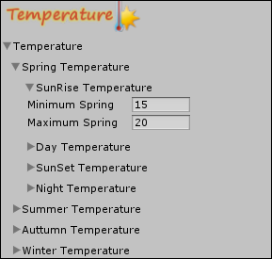
- Temperature:
  - Spring, Summer, Autumn, Winter Temperature:

    - SunRise, Day, SunSet, Night Temperature:

      - Minimun: The minimum temperature depending of the phases and depending of the season too.
      - Maximum: The maximum temperature depending of the phases and depending of the season too.

10- WEATHER:
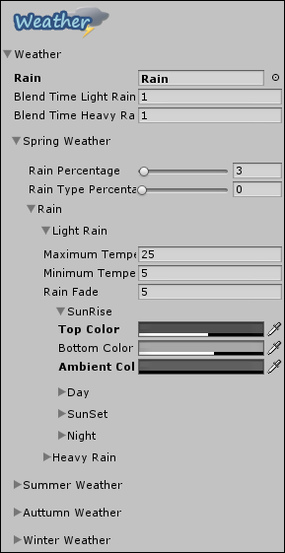
- Weather:
  - Rain: You need to set up here the rain (The prefab contains it).
  - Blend Time Light Rain: Time for the transition of the colors between normal and light rain.
  - Blend Time Heavy Rain: Time for the transition of the colors between normal and heavy rain.

  - Spring, Summer, Auttumn, Winter:
    - Rain Percentage: This is the percentage of the rain if you put it 100 all the days will have rain.
    - Rain Type: This is the percentage of the light or heavy rain, 0 is light and 100 is heavy.
    - Rain
      - Light Rain:
        - Minimum Temperature: You can set up when the rain occurs, for example if the temperature is -5 maybe you don't want the possibility of rain :)
        - Maximum Temperature: You can set up when the rain occurs, for example if the temperature is 40 maybe you don't want the possibility of rain :)
        - Sun Rise, Day, Sun Set, Night:
          - Top Color: Top Color of the sky when the rain occurs.
          - Bottom Color: Bottom Color of the sky when the rain occurs.
          - Ambient Color: Ambient Color when the rain occurs.

      - Heavy Rain:
        - Minimum Temperature: You can set up when the rain occurs, for example if the temperature is -5 maybe you don't want the possibility of rain :)
        - Maximum Temperature: You can set up when the rain occurs, for example if the temperature is 40 maybe you don't want the possibility of rain :)
        - Sun Rise, Day, Sun Set, Night:
          - Top Color: Top Color of the sky when the rain occurs.
          - Bottom Color: Bottom Color of the sky when the rain occurs.
          - Ambient Color: Ambient Color when the rain occurs.

